**Defining HTF PD Arrays**

Theres a hierarchy of PD arrays

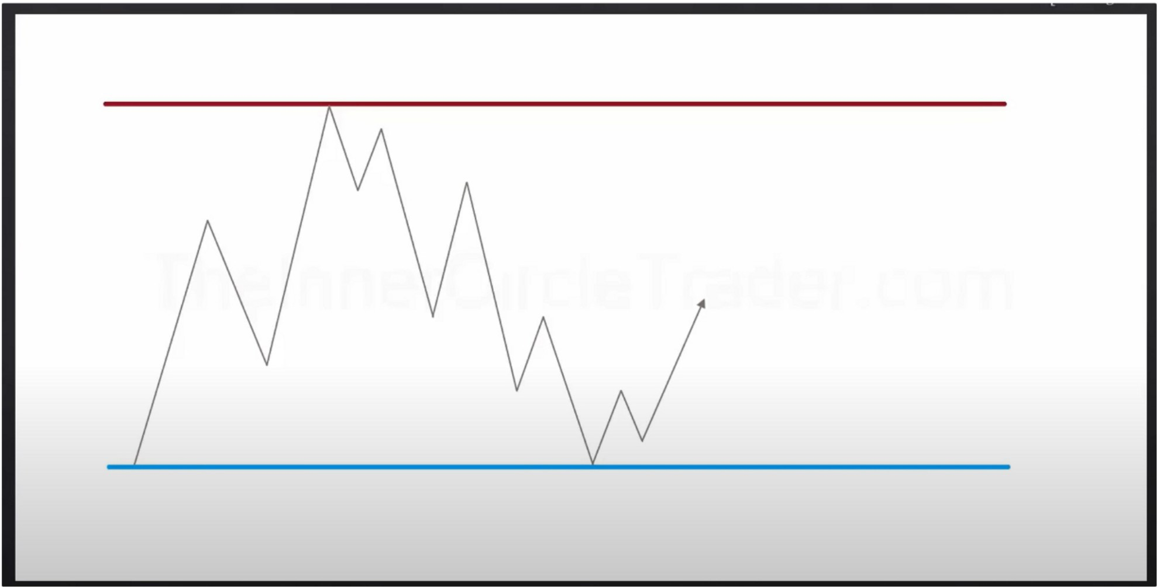When we look at charts we want to see if were in a premium or discount market When looking at HTFs there may be LTFs PD arrays that we cant see on the HTF

Price moves from a level of discount to a level of premium to a level of discount. Between the red line and the blue line they are extremes, in the middle is equilibrium or balance. Buying imbalance, is when price goes above EQ or into that red level that would be resistance premium, selling imbalance is when price goes below EQ into the blue level that would be seen as discount support.

Were going to look at the order of how they form and how to use them where were at in the market place.

When we look at price we want to see where price has moved away from an old high and its dropping from an area of premium, until it gets to discount. The alga will move it back and forth until something significant happens in the market place and it drives the market 1 sided, otherwise it will just look for liquidity based on premium and discount

When time and price agree thats where profitability is

We have no idea how long it will take to see a displacement, no one knows how long it will take for a setup to play out

Its not going to be a straight line to the target

|  |  |  |  |
| --- | --- | --- | --- |
| **Markr1Pd«** |  |  |  |
|  |

|  |  |  |  |
| --- | --- | --- | --- |
|  |  |  | **Futu Prict** |
|  |  |

Price will move from discount to premium because discount cant say very long This teaching will show you which PD array you should look at

The PD arrays are in order of importance



onthlv Premium

**Old High\Low Rejection Block Bearish Orderblock Fair Value Gap Liquidity Void Bearish Breaker**

**Mitigation Block**

**earish rem·um Arrays**

**Equilibrium**

**Mitigation Block** --­ **Bullish Breaker Liquidity Void**

**Fair Value Gap Bullish Orderblock Rejection Block**

-====- **Bull·sh Discount Arrays**

**Old Low\High**

Monthlv Discount

When were at EQ and we look up for premium arrays to resell at, we will look first at where is the nearest mitigation block, there may not be one okay so thats checked off. Where is the nearest breaker, there isnt a breaker either okay also checked off. But if there is one then you would expect price to trade up into that breaker and expect some selling to go lower and once we go past EQ we would be set to go to the monthly discount level. But lets assume the mitigation and breaker arent there, then the next thing we would look for in the hierarchy is a liquidity void, is there a range that needs to be closed in. Maybe the liqudiity void isnt clear, okay its not there so thats also checked off. Next thing, FVG, again that might not exist either. Go to the next thing, bearish orderblock, thats probably going to be there chances are very high that a bearish orderblock is going to be there.

So this is the hierarchy, a mitigation block will be considered first before a bearish orderblock because a bearish orderblock is going to way higher up in premium, mitigation block is the lowest. Mitigation and breaker blocks are generally mitigation blocks, but mitigation blocks generally occur lower then breakers. Bearish breaker will be below the orderblock and will likely stop you from having the high probability orderblock trade, so whenever theres a clear breaker then don't expect the bearish orderblock to be hit because they most likely want to keep the price lower.

If there isnt an obvious bearish orderblock, and theres very little times that happens but we will talk about that when we come to entry techniques. But if there isnt a bearish orderblock then we would look at a rejection block, which will be just above the bodies of the candles and we would expect the bodies to be ran out.

And ultimately a run on the old high, then we would be really in heavy in premium

Why does the premium array have old low? Well if youre on a very low end downtrend then you might be rallying upto an old low and we might be up in heavy premium if it has been rallying up for a while. It may need to run out an old high as well to get there.

So basically your scaling the grade of how much importance youre going to have on each one these PD arrays, were not just listing the things, theyre put in an order of significance.

First thing we look for is, is there a mitigation block i should consider? Then bearish breaker, etc. Its in an order of looking to the lowest to up

The order of importance, the highest of the premium array is old high/low, then rejection block, bearish orderblock etc etc.

The farther we go up in the list the more deeper in premium we go. Some arrays might prevent you from seeing the next higher array, for example when we see a breaker chances are were not going higher then that, you wont generally get up to the liquidity void then. If theres a breaker below the liquidity void that liquidity void may stay open basically.

Again, when we have a breaker, chances of seeing price trading back into the liquidity void are slim, of course it can happen once the breaker is disrespected

Without a breaker, we would expect the void to be filled and gap to be filled to trade into an orderblock

We look at the arrays to get in or to take profits, so we can also use them as targets

Wee ly Premium

**Old High\Low Rejection Block Bearish Orderblock Fair Value Gap Liquidity Void Bearish Breaker**

**Mitigation Block Equilibrium**

**Mitigation Block Bullish Breaker Liquidity Void Fair Value Gap Bullish Orderblock Rejection Block Old Low\High**

Weeklv Discount

Same thing on the weekly

# ailv Premium

**Old High\Low Rejection Block Bearish Orderblock Fair Value Gap Liquidity Void Bearish Breaker**

**Mitigation Block Equilibrium**

**Mitigation Block Bullish Breaker Liquidity Void Fair Value Gap Bullish Orderblock Rejection Block Old Low \High**

# Dailv Di<;count

And again, same hierarchy for the daily

Arjo I Twitter, lnstagram I Linktree

Linktree. Make your link do more.

, https://t.co/HhmmTN1fUI

JavaScript is not available.

***"!I*** https://twitter.com/arjoio